**Task 1-2**

**Bug reports**

**https://oxford-med.com.ua/**

| Issue type | bug report 001 |
| --- | --- |
| Summary | The login page is not translated into English in the english version of the site. |
| Environment | Mac OS Chrome, Safari, Mozilla |
| Steps to reproduce | 1. Press “language change” icon in the header of the site 2. Choose English language 3. Press “login” icon in the header of the site |
| Actual result | The login page is not translated into English in the english version of the site. |
| Expected result | The login page is in English in the english version of the site. |

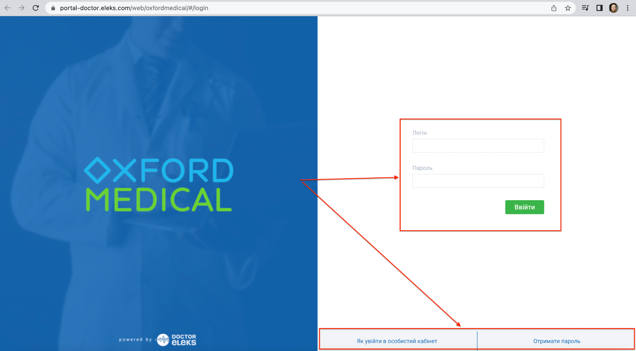

| Issue type | bug report 002 |
| --- | --- |
| Summary | The map area has no indent on the sides |
| Environment | Mac OS,Chrome, Safari  Windows 10 Chrome, Mozilla |
| Steps to reproduce | 1. Open <https://oxford-med.com.ua/contacts/> 2. Pay attention to the sides of the map |
| Actual result | The map area has no indents on the sides |
| Expected result | The map area has the indents on the sides |

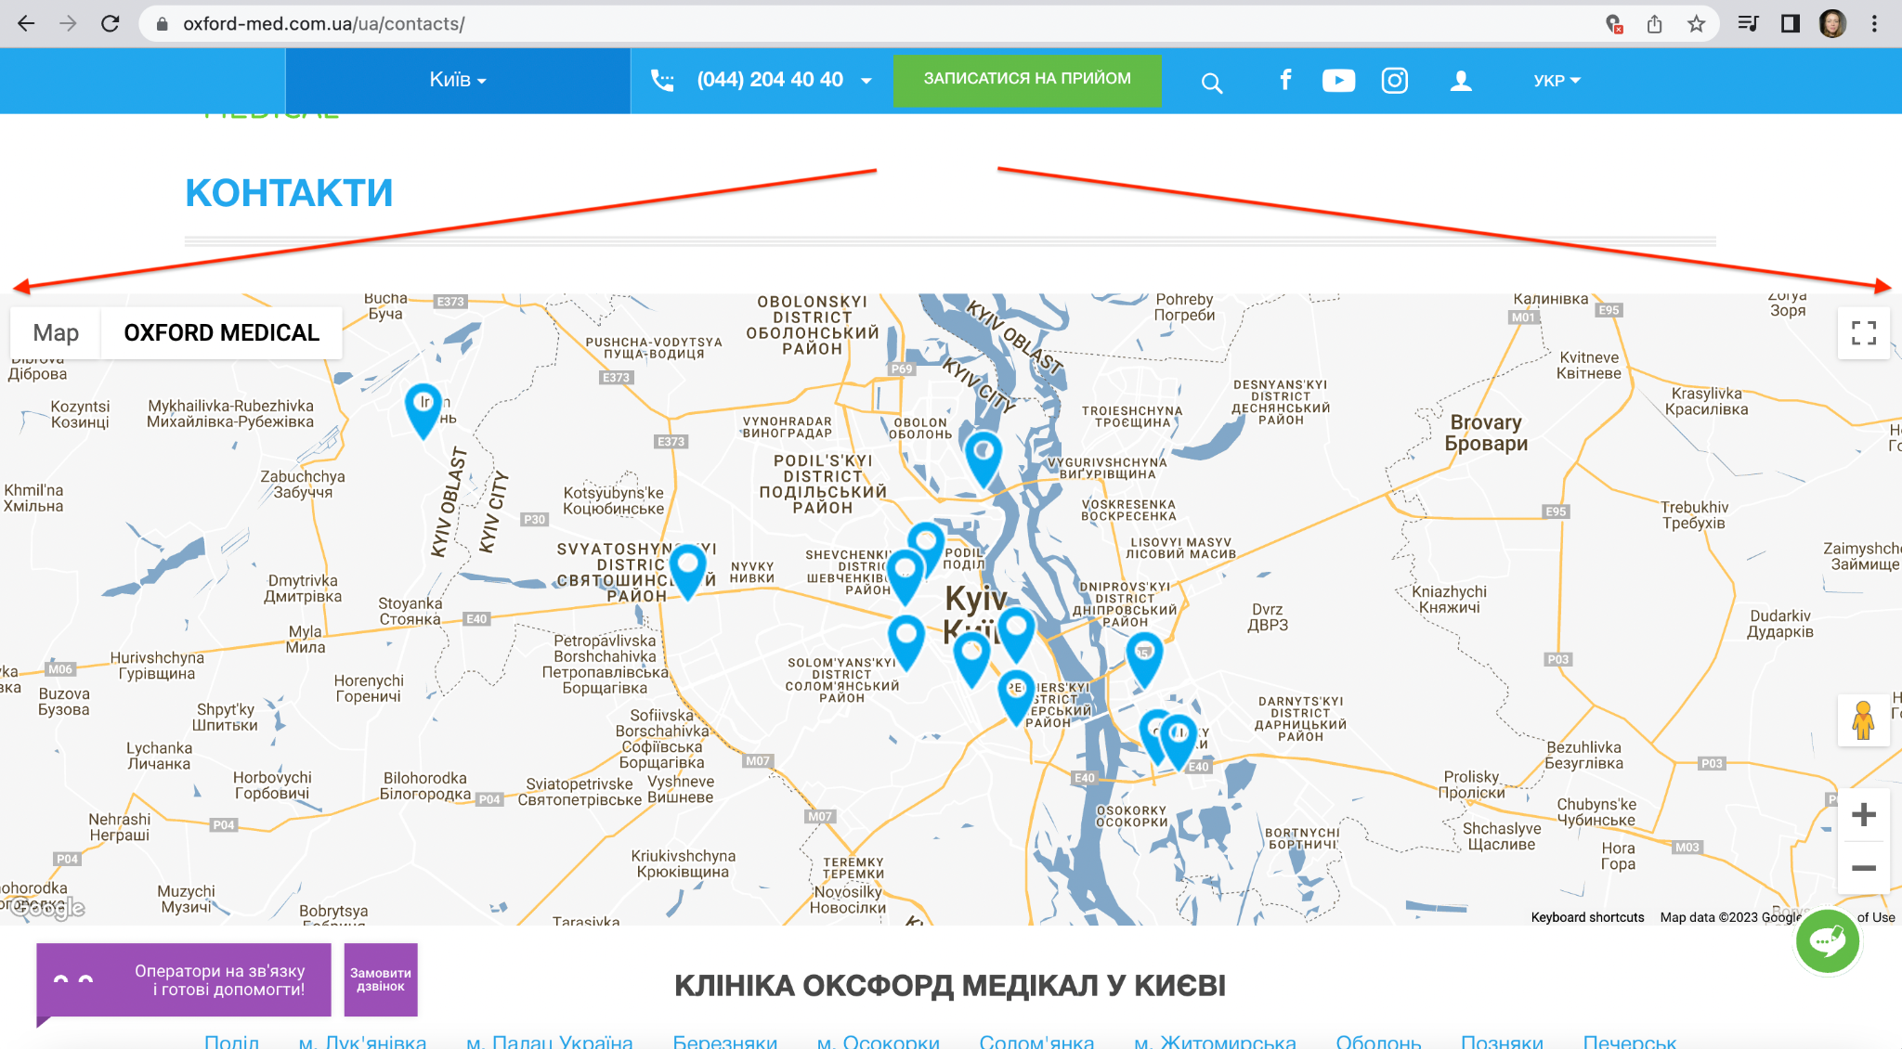

| Issue type | bug report 003 |
| --- | --- |
| Summary | There are two different headers font sizes on the contact page |
| Environment | Mac OS,Chrome, Safari  Windows 10 Chrome, Mozilla |
| Steps to reproduce | 1. Open <https://oxford-med.com.ua/about/> 2. Pay attention to the headers |
| Actual result | There are two different font sizes on the contact page headers |
| Expected result | The pages headers have the same font sizes |

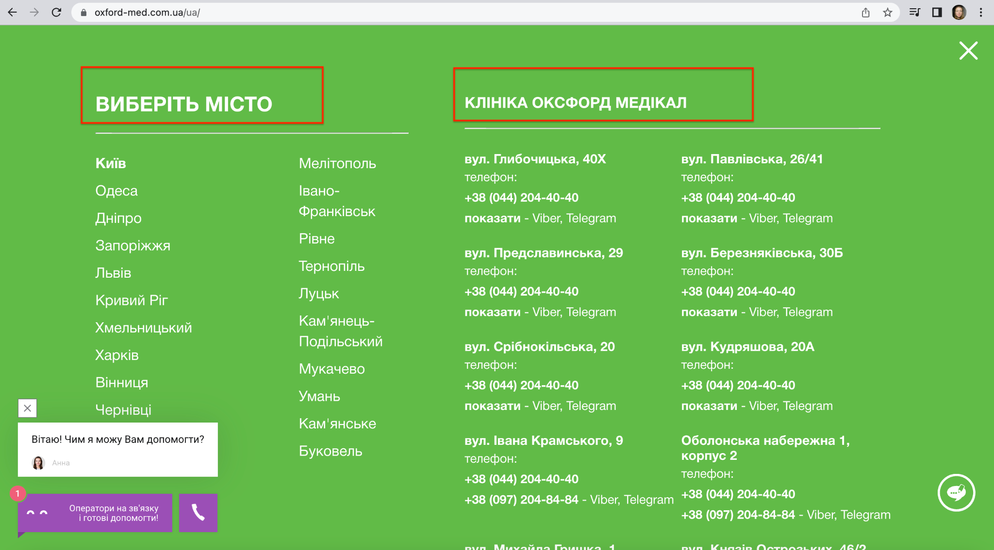

| Issue type | bug report 004 |
| --- | --- |
| Summary | The button name “ЗАПИСАТИСЯ НА ПРИЙОМ” is not vertically centralized |
| Environment | Mac OS Chrome, Safari |
| Steps to reproduce | 1. Open <https://oxford-med.com.ua/> 2. Pay attention to the headers |
| Actual result | The button name “ЗАПИСАТИСЯ НА ПРИЙОМ” is not vertically centralized |
| Expected result | The button name “ЗАПИСАТИСЯ НА ПРИЙОМ” is vertically centralized |
| Special notes | ***The bug does not reproduce in the Windows 10 OS |

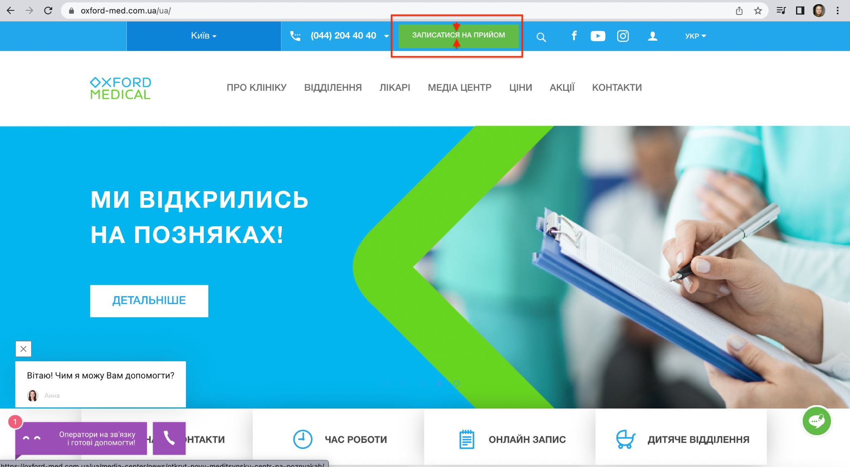

| Issue type | bug report 005 |
| --- | --- |
| Summary | There is empty space in the contact page in the english version on the site. |
| Environment | Mac OS,Chrome, Safari  Windows 10 Chrome, Mozilla |
| Steps to reproduce | 1. Go to <https://oxford-med.com.ua/en/> 2. Scroll down to the contacts information |
| Actual result | There are empty spaces in the contact page in the english version on the site. |
| Expected result | The contact information of the clinics must be situated in the chess order |

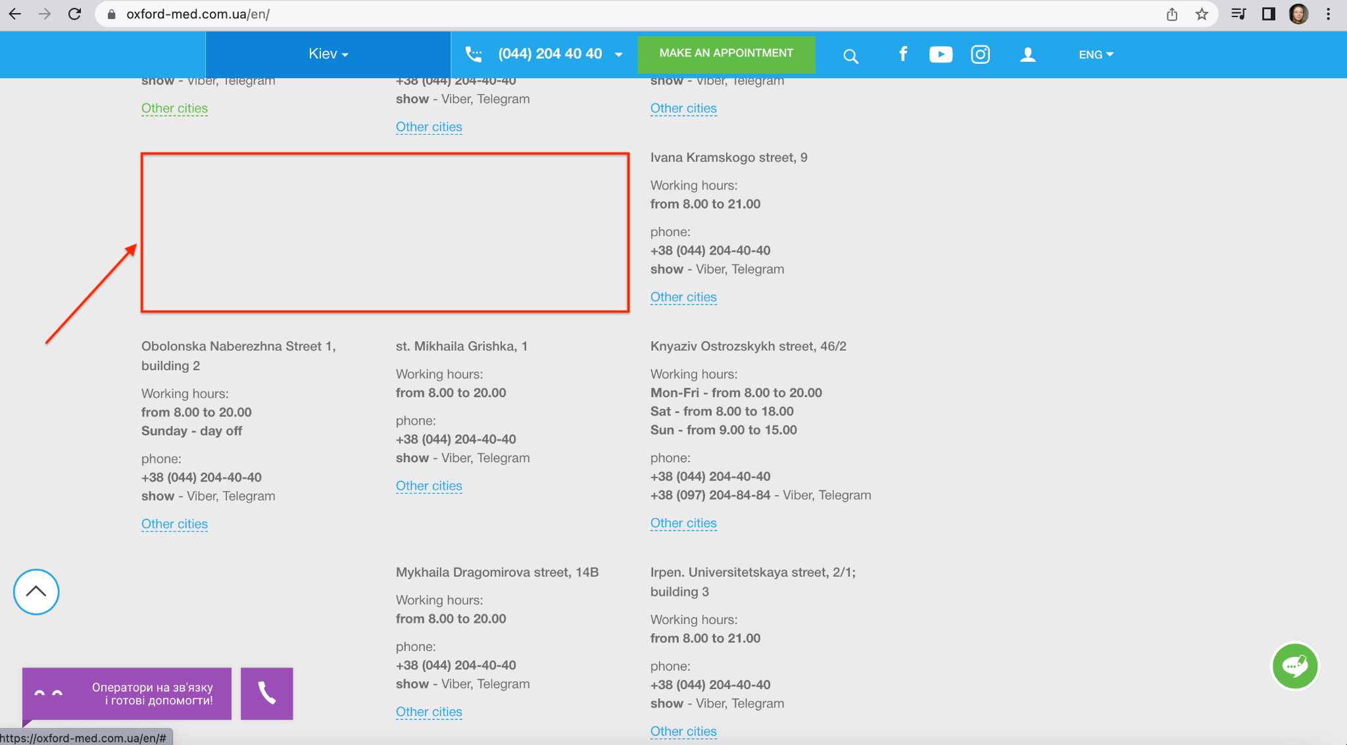

**Task 3**

* номер телефону у хедері
* ім’я асистента при виклику чата допомоги
* кнопка “інші міста” у футері сайту
* Placeholder “ім’я” у формі “ЗАПИСАТИСЯ НА ПРИЙОМ”

|  |  |
| --- | --- |
|  |  |